Pennine Pizza Works
HASAN Uzsoy, REBECCA WOOD, KELLY-MARIE ALLUM

Analysis

The brief in summary
A company named Pennine Pizza works is a small independent pizza takeaway place in which the shop currently takes orders by using a phone and at the counter. Staff write the orders on paper and use calculators to work out the final price of the order but however this has been causing problems for the takeaway place when customers decide to order several more pizzas alongside with different sizes, adding toppings, requesting delivery or qualifying for a discount which made the owner realize that the staff sometimes make mistakes while adding the order total or even when applying for discount or adding the delivery charge.
The business wants a simple computer program which has the function to calculate customer orders in a more accurate method in which they have asked the team to design, build, test and prepare a basic pizza ordering system which will be done by using flowgorithm.

Data sheet supplied by the client
Item | Rule
Minimum number of pizzas | 1
Maximum number of pizzas | 6
Small pizza | £3.25
Medium pizza | £5.50
Large Pizza | £7.15
1 extra topping | £0.75
2 extra toppings | £1.35
3 extra toppings | £2.00
4 or more extra toppings | £2.50
Discount | 10% discount if the order subtotal is over £20 before delivery is applied
Delivery charge | £2.50 if delivery is requested

1.3 Requirements table
Input ID | Requirements | Type
R1 | Staff enters the customer’s name, address and phone number. | Input
R2 | Staff enters the number of pizzas ordered. | Input/rule
R3 | Staff enters the size of each pizza. | Input
R4 | Staff enters the number of extra toppings for each pizza | Input
R5 | Whether or not if the delivery is required | Input

1.4 Input – Process – Output (IPO) table
Input | Process | Output
Customer Name, Address and phone (R1) | Make sure it doesn’t stay blank. | Customer details will appear on the bill.
Number of pizzas (R2) | The numbers must be correct and accurate. | Number of Pizzas ordered will show on the bill.
Size of each pizza (R3) | The size of each pizza would need to be correct. | Size of pizzas ordered is presented on the bill.
Number of toppings for each pizza (R4) | The number of toppings for each of the pizzas should be correct. | The total of toppings for the pizzas ordered will be listed on the bill.
Optional delivery (R5) | Delivery needs to be chosen if needed for a specific order if not then there is no order needed. | There would be the choice if delivery is required or if it isn’t for certain specific orders.

1.5 Assumptions and questions for the client

1.6 Validation rules

1.7 Computational thinking applied

2. Design

2.1 Decomposition: structure chart
Pizza shop structure chart. 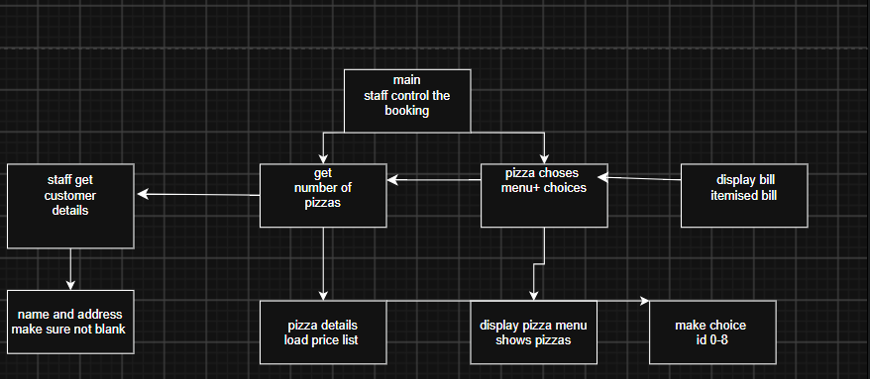

2.2 Main flowchart design
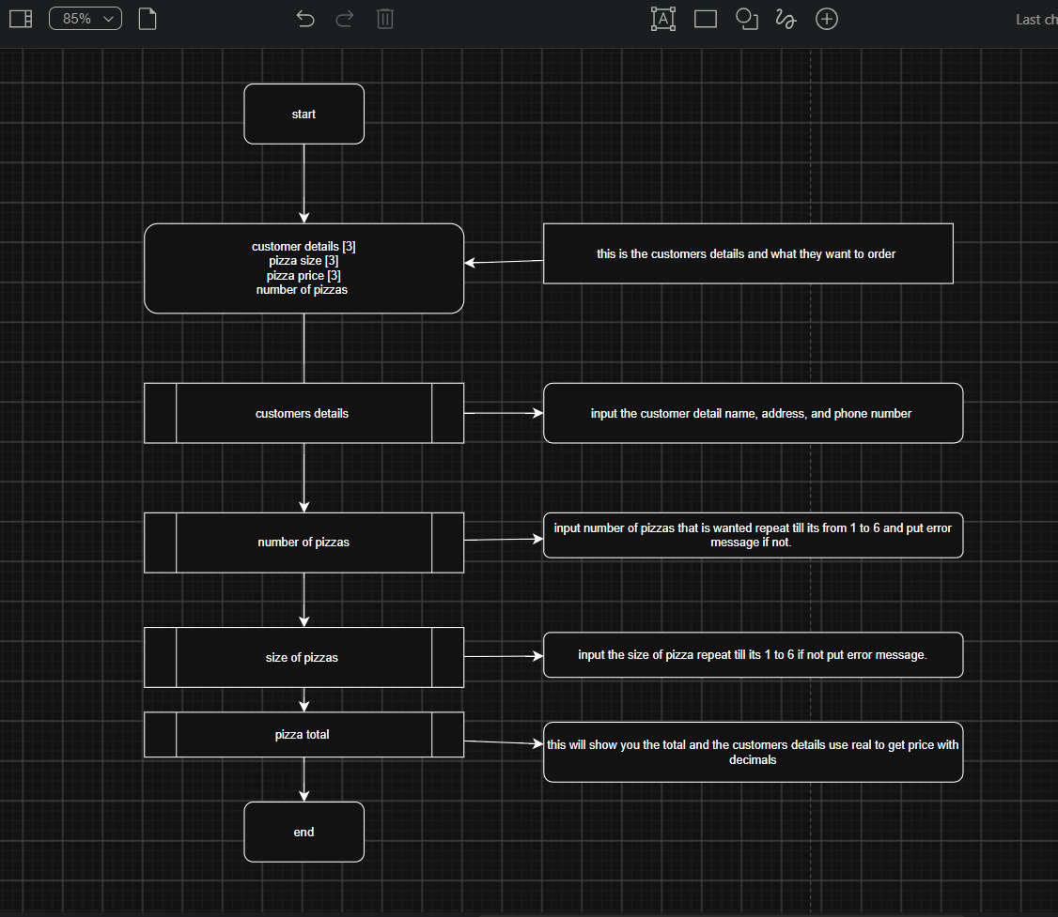

2.3 Data plan
Data structures (arrays)
Array | Type | Size | Declared in | Holds | Example
customerDetails | string | 3 | main | 0] name, [1] address, [2]  phone number. Filled by  getCustomerDetails.  shown by displayBill. | customerDetails[0]
Pizzasize | string | 3 | main | The size of each pizza. | Pizzasize = small medium and large
numberoftopping | integer | 4 | main | This will calculate the toppings as a whole. | Pizza toppings= 2 whole numbers
pizzaprice | real | 3 | main | The total of the pizzas because this is a decimals | Pizza price 7.15
toppingprice | real | 4 | main | This is the same as above.

2.4 Subroutine specifications
Variables
Variable | Type | Used in | Purpose | Validation
Numberofpizzas | integer | main | How many pizzas would they like to order. | This is valid by the if as this say yes carry on to next part if no then you cant go any further.
details | String | checkBlank  (parameter and  return value) | The customer detail being  checked | Must not be blank
choice | interger | Make choice | The pizza typed by the user | 0 to 6; checked by a  While loop before it is  stored
loop | interger | Get customers details,displys pizza size, topping you want and displaying the bill | for loop counter (local to  each subroutine) | Set by each For loop
Total | Real | displysbill | Running total of the chosen pizzas price. | Real works out in decimals for the total

2.5 Algorithm: pseudoco de (Generated) 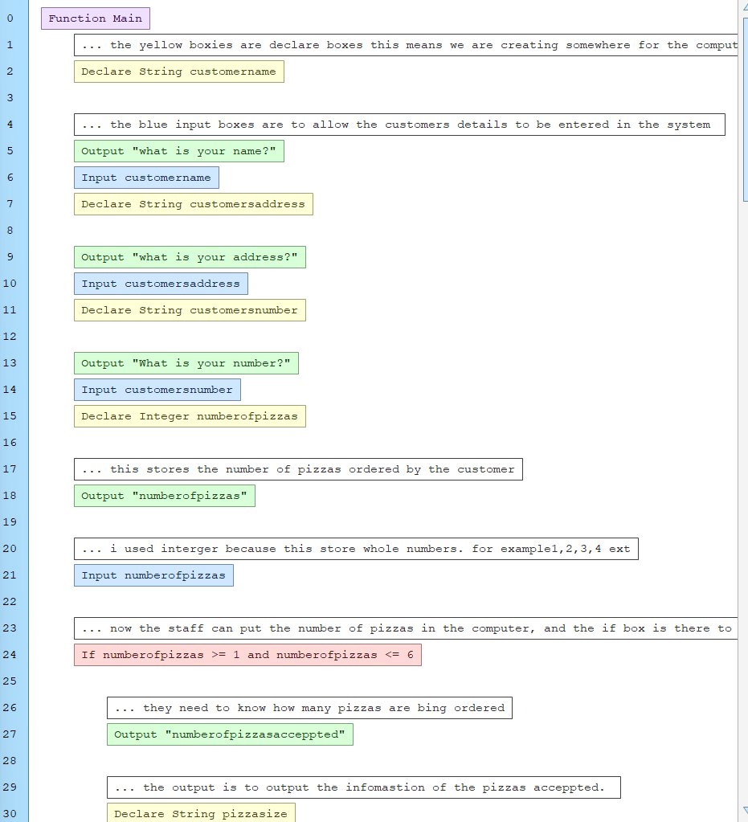
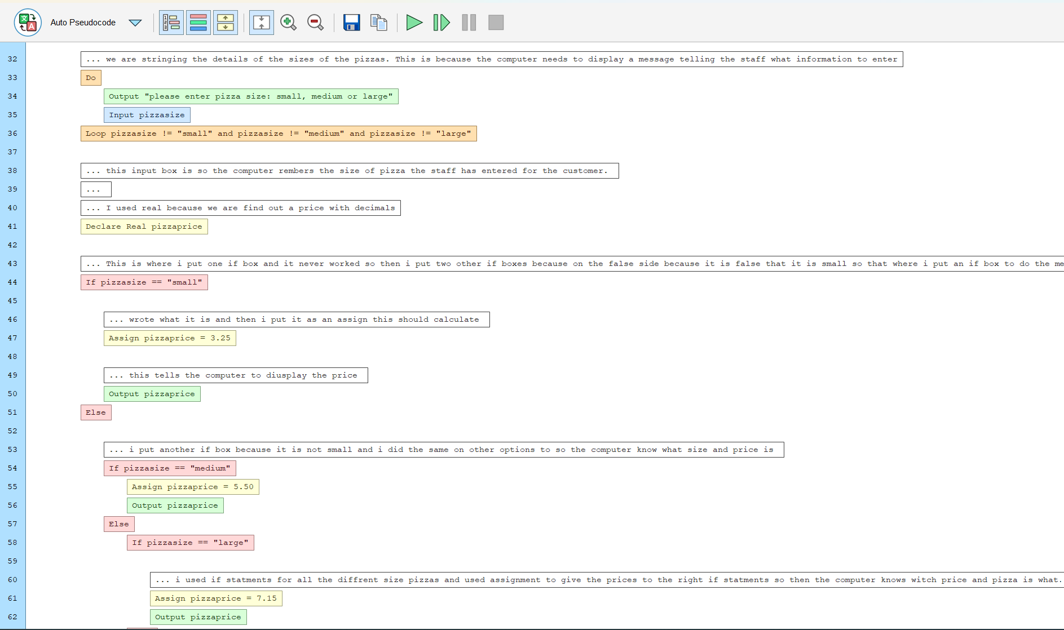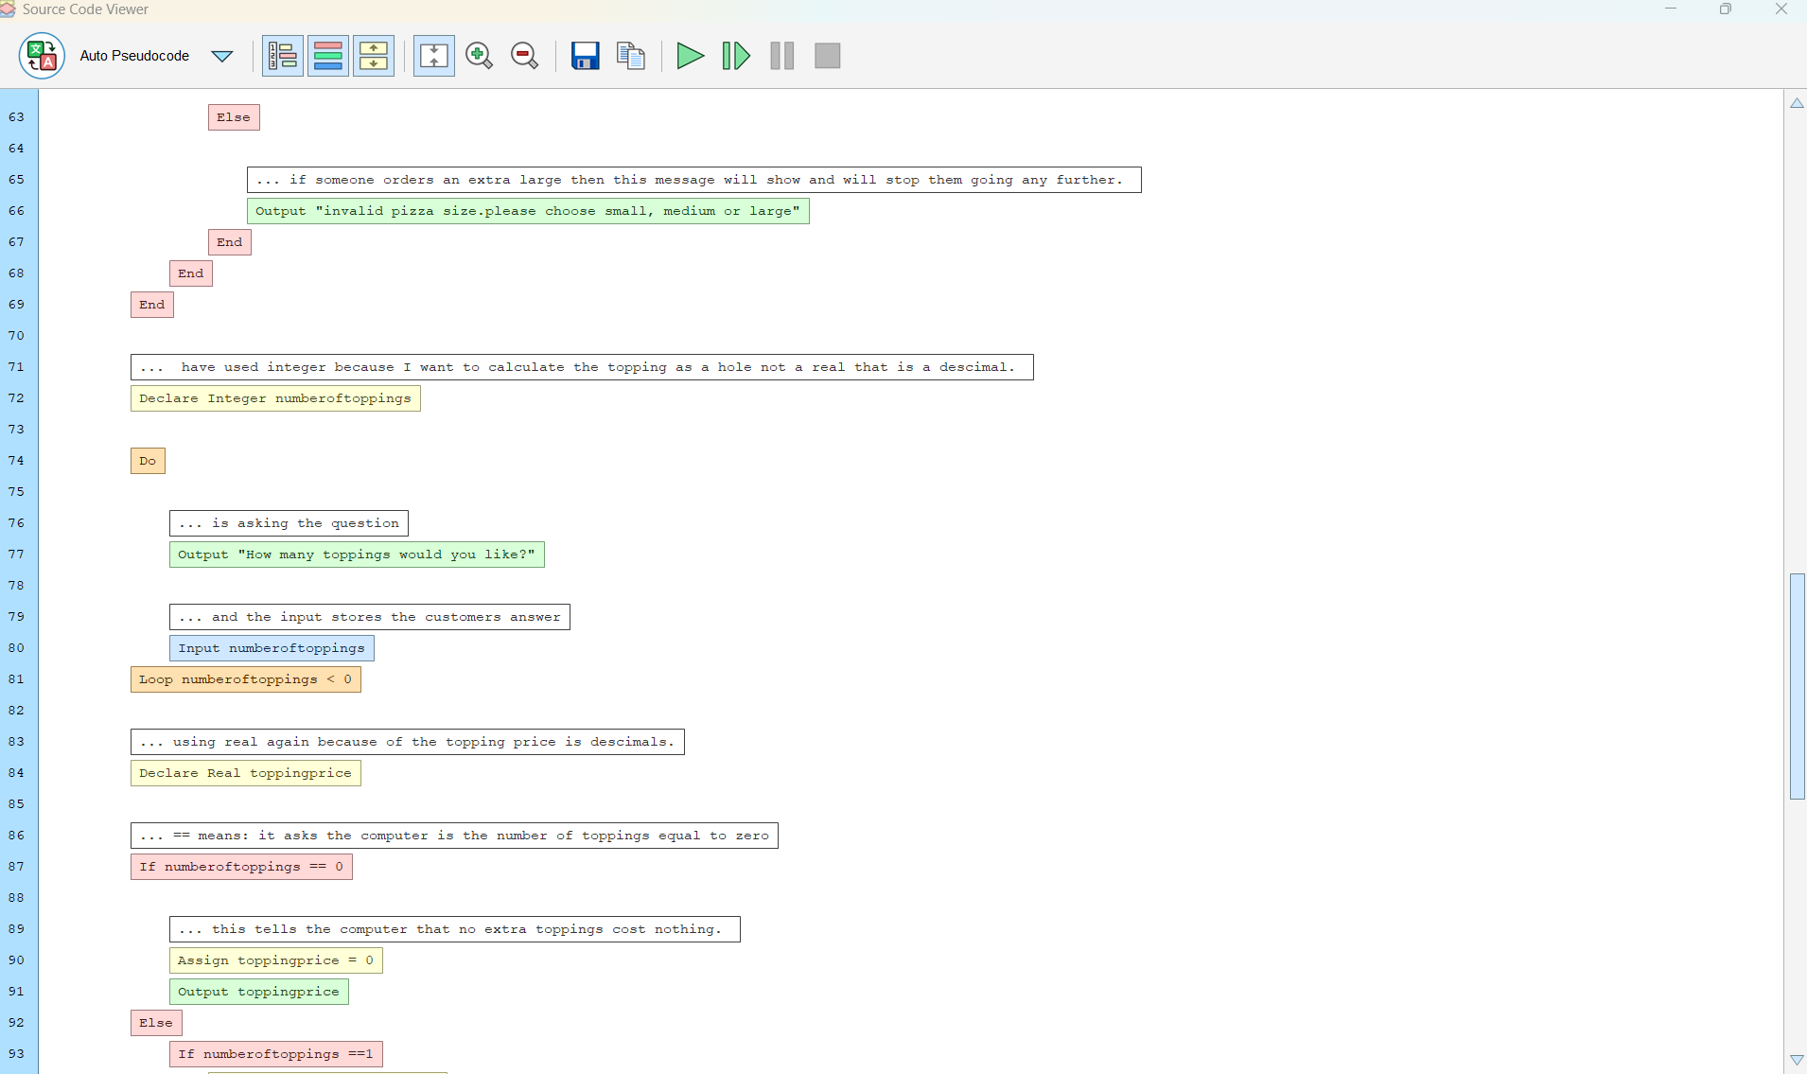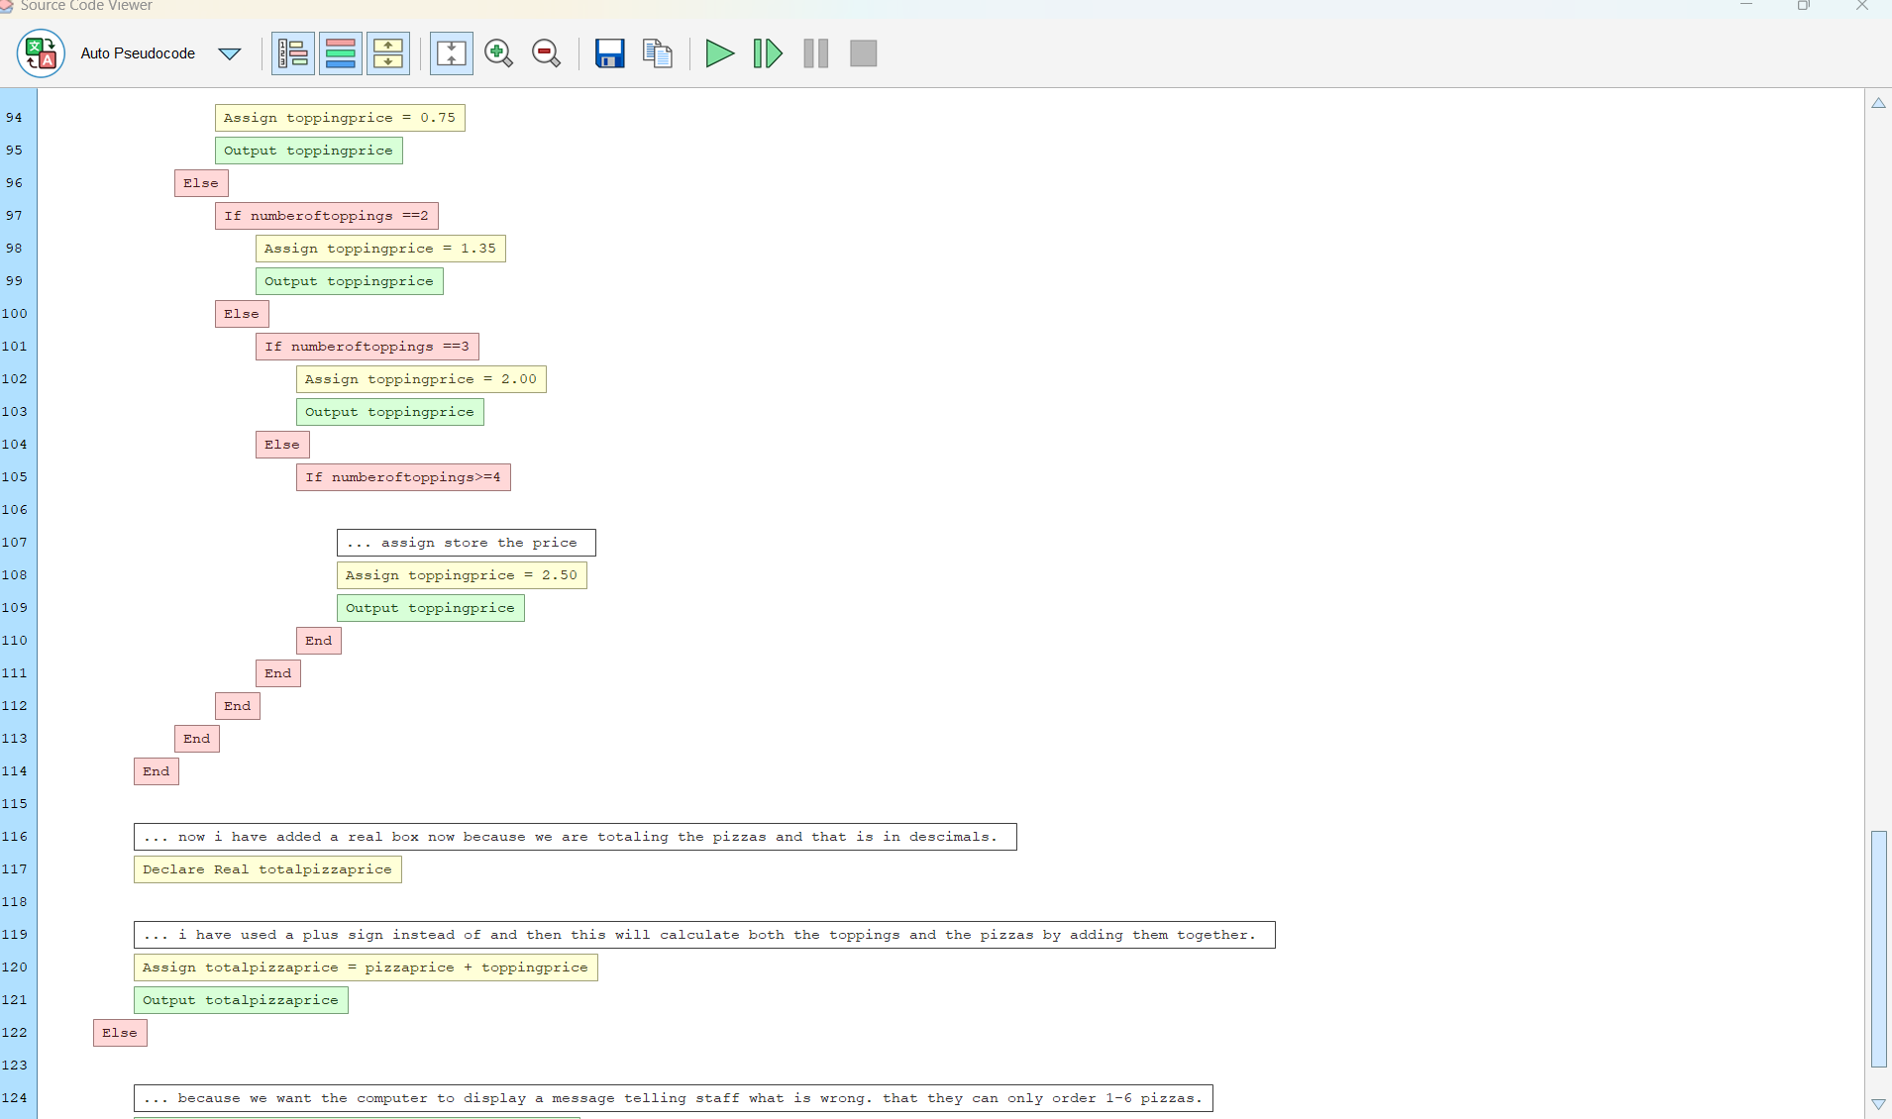

3. Implementation

3.1 How to run the program
1. Open Flowgorithm and choose File › Open, then select pizzawork.fprg.
2. Use the function list on the toolbar to switch between Main and the other subroutines.
3. Press Run. Type each answer into the input box and press Enter.
4. Open the Variable Watch window to see the arrays fill as the program runs.

3.2 Program flowcharts
Each figure shows one function of pizzaworkshop.fprg, shape by shape, including its comments
(dashed boxes). Key: yellow = declare / assign, green = output, blue = input, purple = call, red diamond = decision, hexagon = loop.

3.2.1 Main and 3.2.2 getCustomerDetails

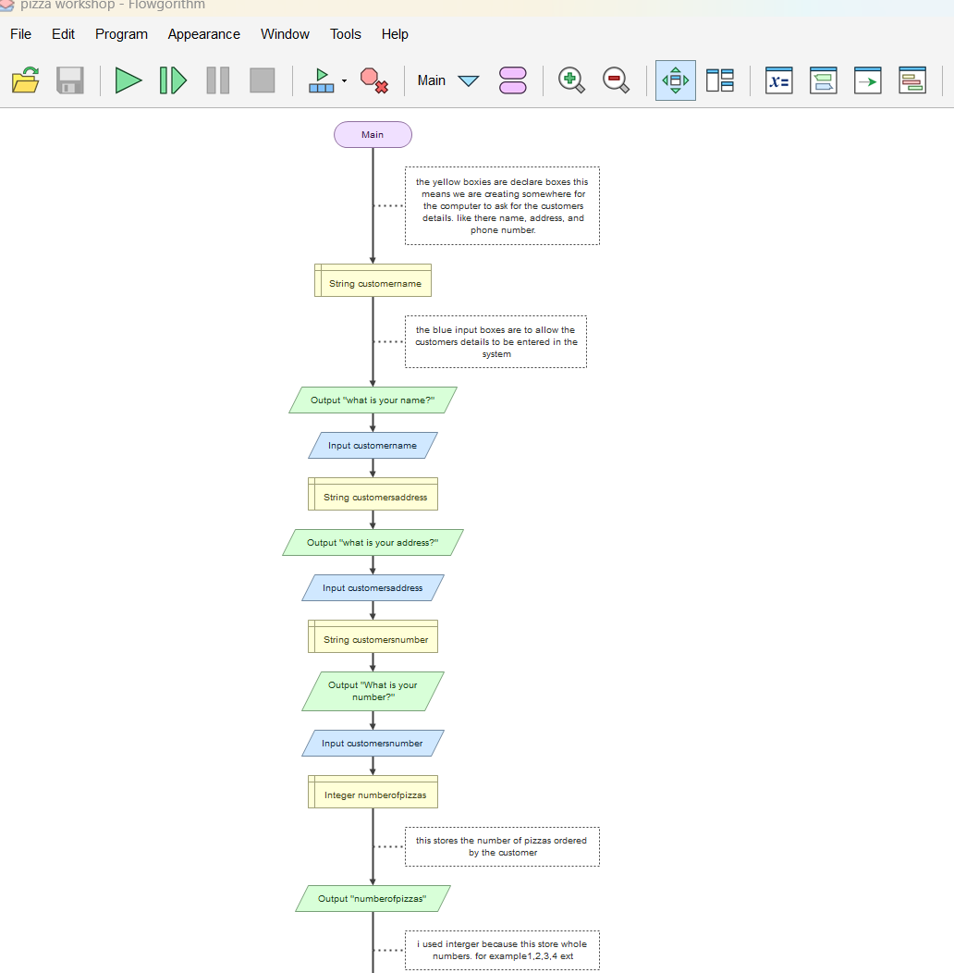

3.2.3 number of pizzas
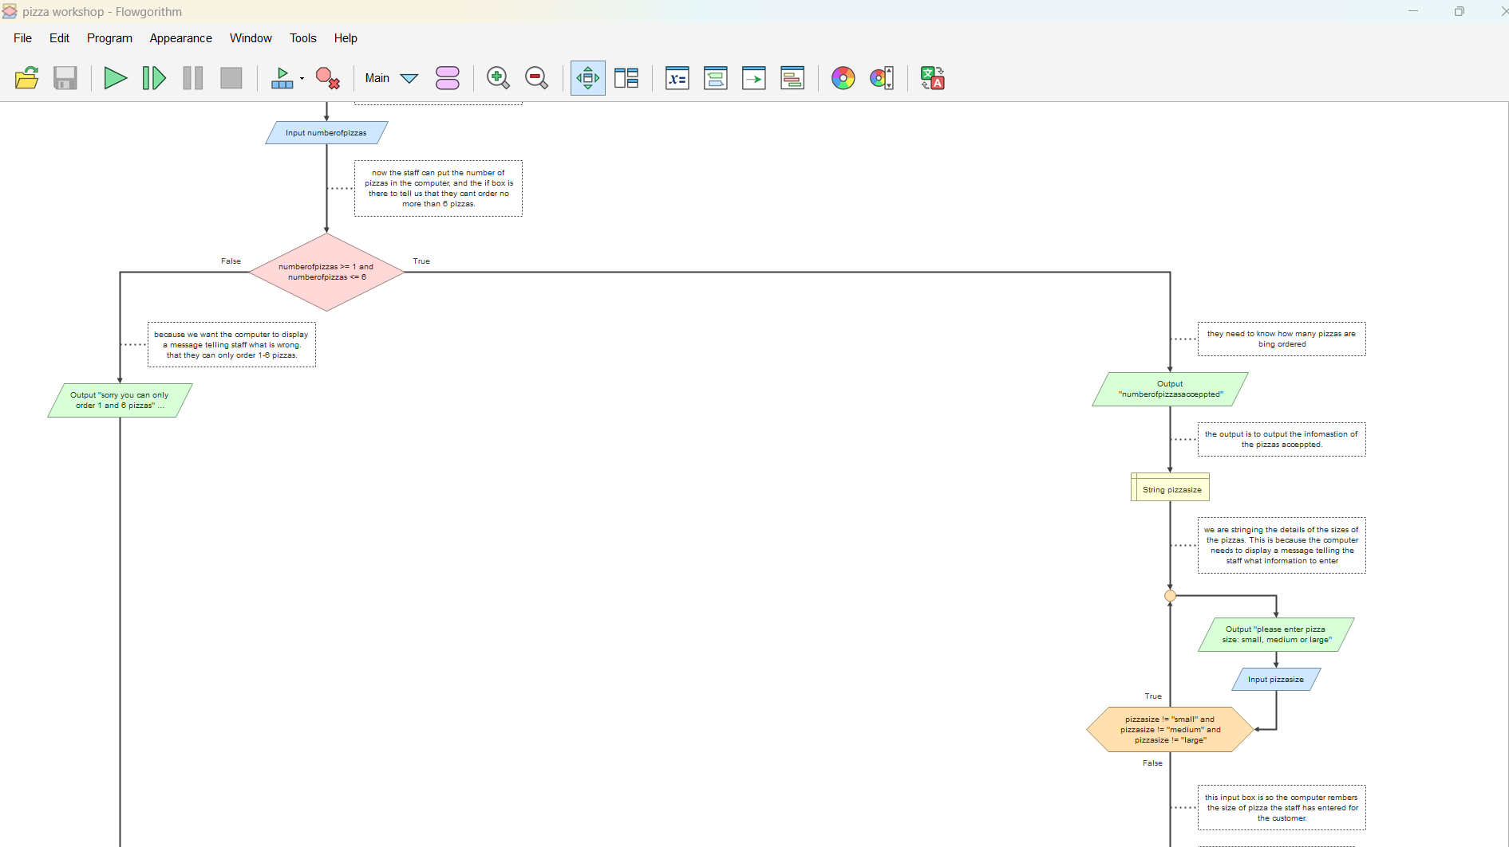

3.2.5 size of pizza
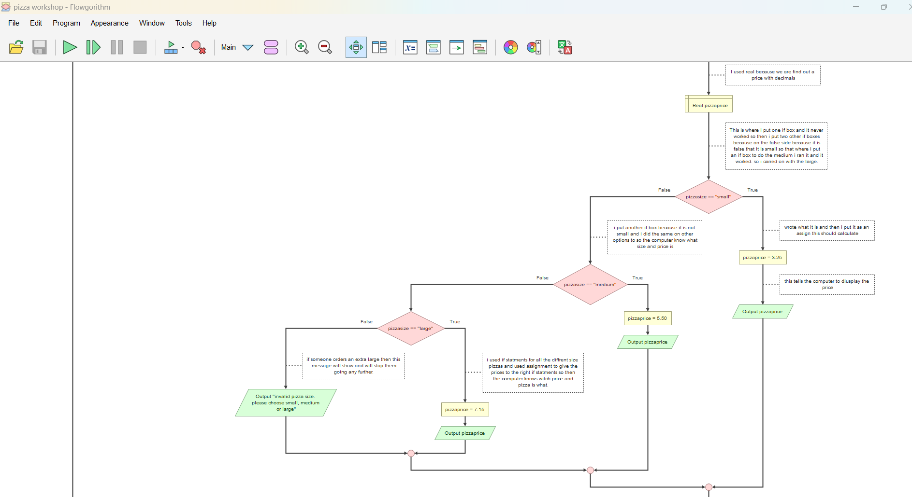

3.2.6 number of toppings
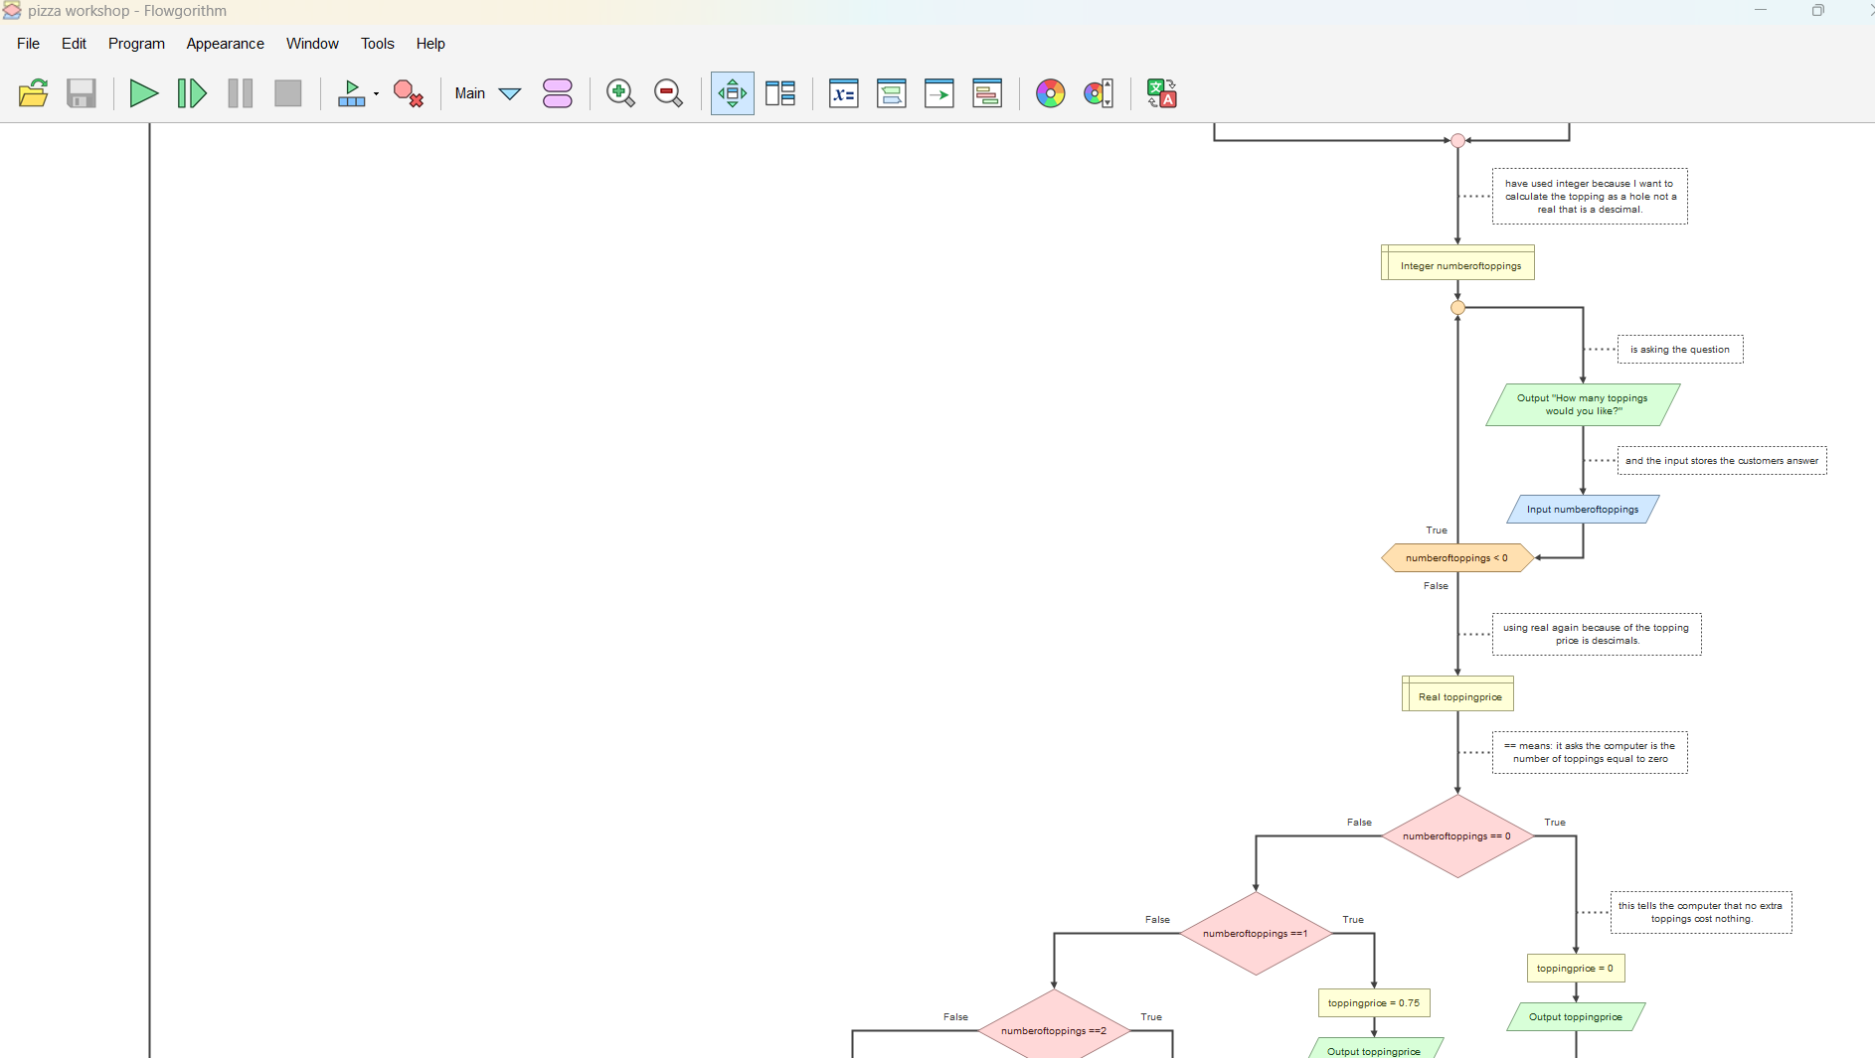

3.2.7 pizza toppings
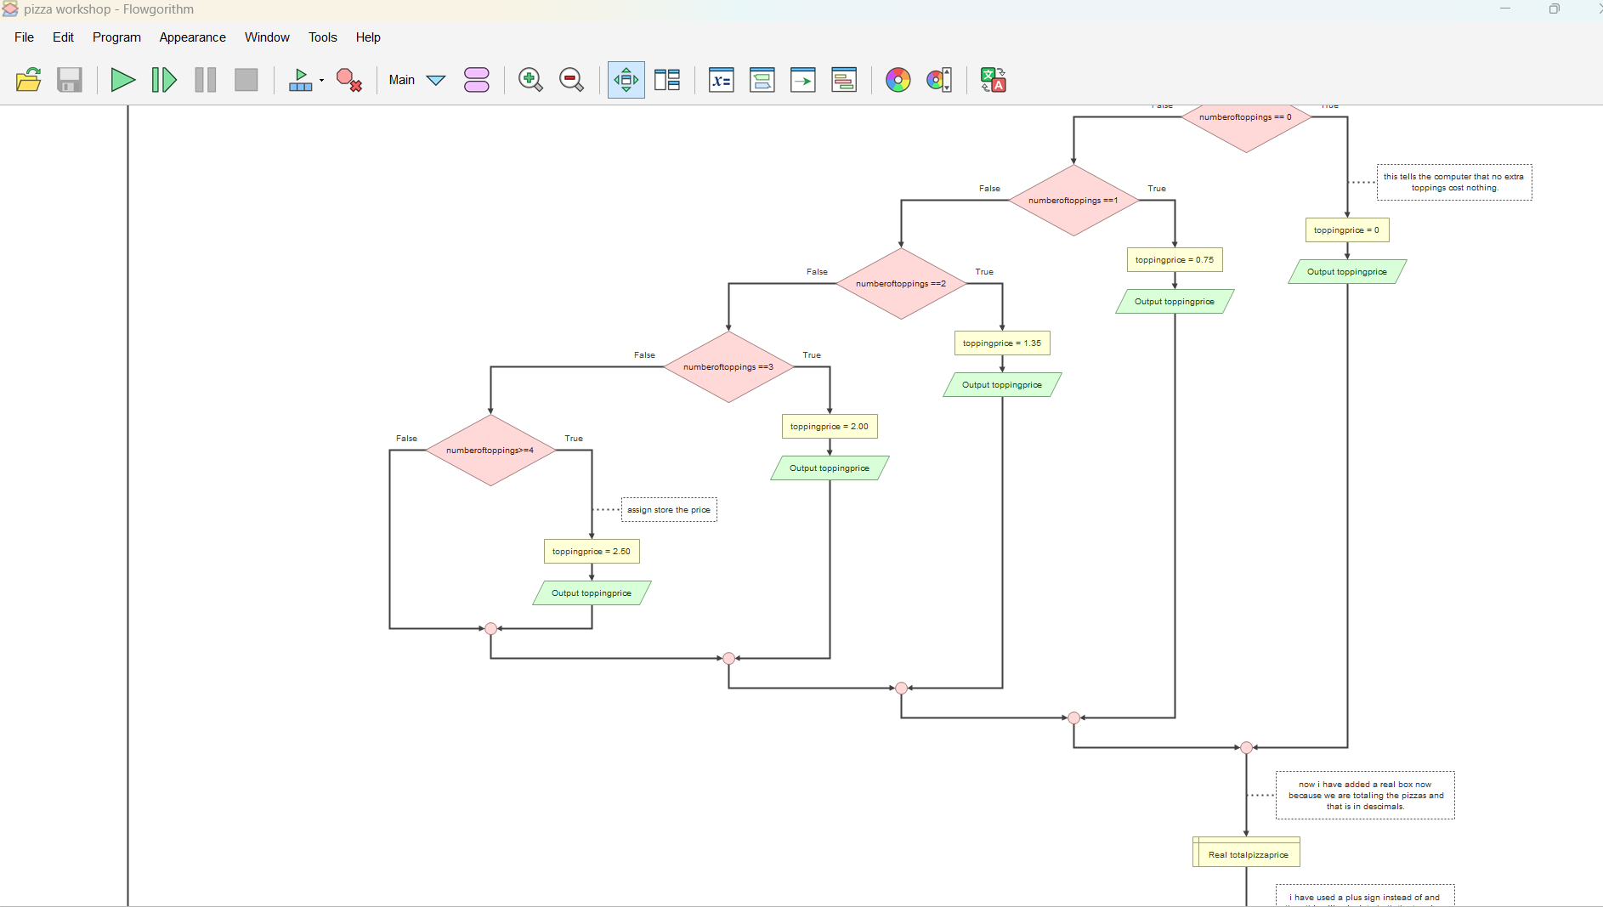

3.2.8 Display bill
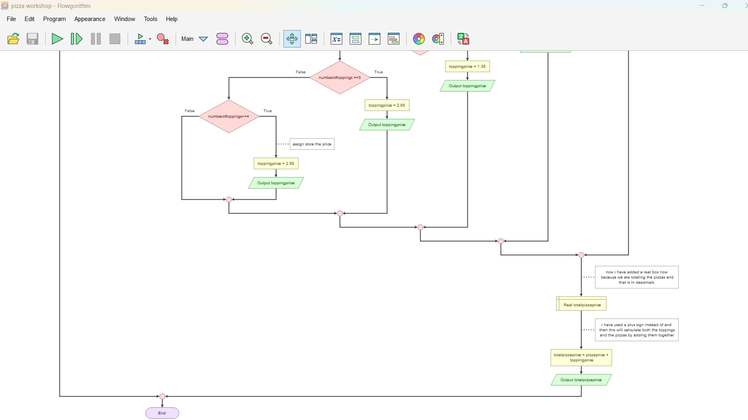

3.3 How the program matches the design
Design decision | How it was implemented
Main flowchart design | Main follows the draw.io design step for step: set up the arrays, then call  getCustomerDetails, number of pizzas, pizza size and display Bill.
Subroutines | Each box in the structure chart is a Flowgorithm function with the parameters and  return type listed in Section 2.4.
Arrays | customerDetails, number of pizzas and pizza size are declared in Main and  filled by subroutines, because arrays are passed by reference.
Validation | Pizza toppings read the amount of topping first and uses a loop to ask again.
Running total | display will add each chosen pizzas price to total inside the same loop that prints the pizzas.
Two decimal places | pizza prices and the total on the bill use real.

3.4 Programming conventions followed
Comments | label each part of the program by purpose (ABSTRACTION, LOOP, VALIDATION)
Meaningful names | in camelCase, such as customerDetails, numberofpizzas and pizzatoppings.
One job per subroutine | so each can be tested on its own
Arrays | related data together and are passed to subroutines in one step.
Every variable is given a value before it is used | which Flowgorithm requires
Small inconsistencies to tidy | pizzatoppings is called as pizzatoppings, and Total is declared but used as total. Both work because Flowgorithm names are not case-sensitive, but consistent spelling is clearer

3.5 Sample run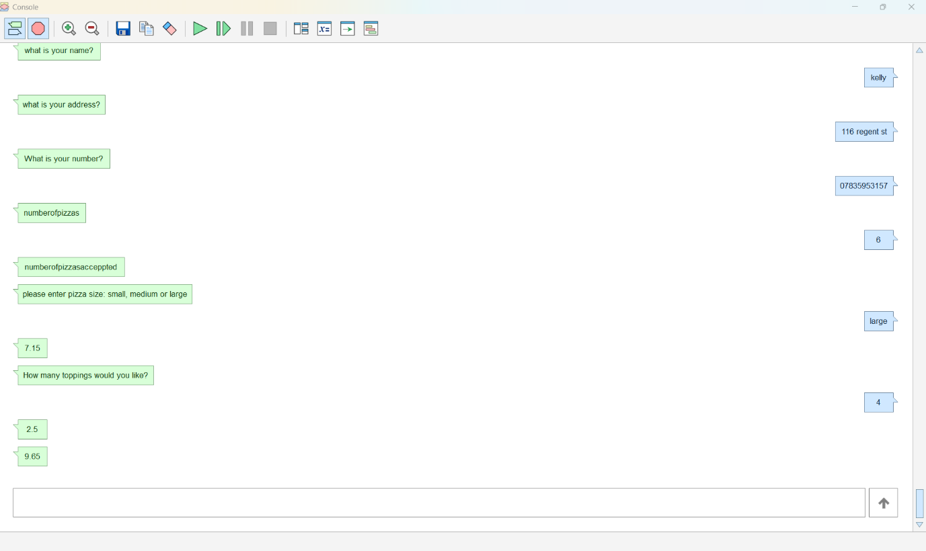

4. Testing

4.1 Test plan and results

4.2 Worked calculation (Test 2)

4.3 Evidence

4.4 Issues found and recommended fixes
Found by | Issue | Recommended fix
Kelly-Marie and Rebecca | There was no questions for the customers details. | I put output boxes with the questions so that they could be answered.
Kelly-marie | Was not repeating the topping. | I put a do loop so it would repeat.
Kelly-marie | Was not totalling in decimals | I used a real variable and that gave me the total correctly.

4.5 Requirements coverage

